TESTING POWER BI REPORTS IN SQL
Create Table
create table hrdata
(
emp_no int8 PRIMARY KEY,
gender varchar(50) NOT NULL,
marital_status varchar(50),
age_band varchar(50),
age int8,
department varchar(50),
education varchar(50),
education_field varchar(50),
job_role varchar(50),
business_travel varchar(50),
employee_count int8,
attrition varchar(50),
attrition_label varchar(50),
job_satisfaction int8,
active_employee int8
)

Import Data in Table Using Query
COPY hrdata FROM 'D:\hrdata.csv' DELIMITER ',' CSV HEADER;

Employee Count:
select sum(employee_count) as Employee_Count from hrdata;
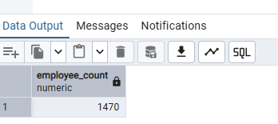
Attrition Count:
select count(attrition) from hrdata where attrition='Yes';
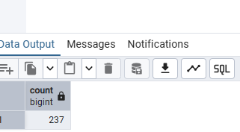
Attrition Rate:
select
round (((select count(attrition) from hrdata where attrition='Yes')/
sum(employee_count)) * 100,2)
from hrdata;
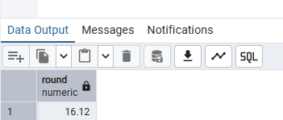
Active Employee:
select sum(employee_count) - (select count(attrition) from hrdata where attrition='Yes') from hrdata;
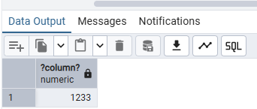

Average Age:
select round(avg(age),0) from hrdata;
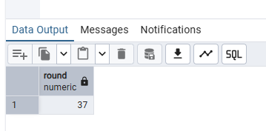
Attrition by Gender
select gender, count(attrition) as attrition_count from hrdata
where attrition='Yes'
group by gender
order by count(attrition) desc;
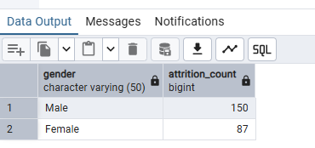

Department wise Attrition:
select department, count(attrition), round((cast (count(attrition) as numeric) /
(select count(attrition) from hrdata where attrition= 'Yes')) * 100, 2) as pct from hrdata
where attrition='Yes'
group by department
order by count(attrition) desc;
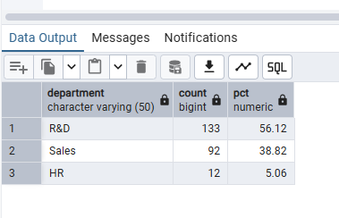

No of Employee by Age Group
SELECT age, sum(employee_count) AS employee_count FROM hrdata
GROUP BY age
order by age;
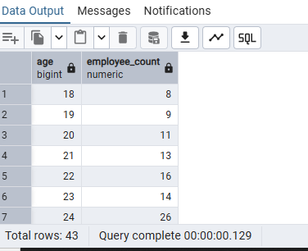

Education Field wise Attrition:
select education_field, count(attrition) as attrition_count from hrdata
where attrition='Yes'
group by education_field
order by count(attrition) desc;
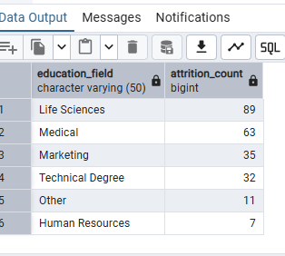
Attrition Rate by Gender for different Age Group
select age_band, gender, count(attrition) as attrition,
round((cast(count(attrition) as numeric) / (select count(attrition) from hrdata where attrition = 'Yes')) * 100,2) as pct
from hrdata
where attrition = 'Yes'
group by age_band, gender
order by age_band, gender desc;
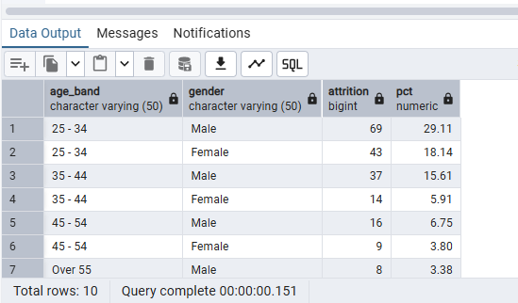

Job Satisfaction Rating
CREATE EXTENSION IF NOT EXISTS tablefunc;

SELECT *
FROM crosstab(
'SELECT job_role, job_satisfaction, sum(employee_count)
FROM hrdata
GROUP BY job_role, job_satisfaction
ORDER BY job_role, job_satisfaction'
) AS ct(job_role varchar(50), one numeric, two numeric, three numeric, four numeric)
ORDER BY job_role;
